Characterizing Extrasolar Planetary Systems

A paper submitted on 15 February 2009
in response to the Astro2010 Decadal Survey
call for science white papers

David Leisawitz, John Carpenter^{b}, William C. Danchiª, John Debes^{a, c}, Drake Demingª, Marc Kuchnerª, William D. Langer^{b,d}, Lee G. Mundy^{e}, Joan Najita^{f}, David Neufeld^{g}, Stephen Rinehartª, Aki Robergeª, Eugene Serabyn^{b,d}, Sachindev Shenoy^{b,h}, Chris Stark^{a,e}, Mark R Swain^{b,d}, Stephen C. Unwin^{b,d}, Edward Wright^{i}, and Harold W. Yorke^{b,d}

Abstract. The quest to detect and characterize exoplanets, and learn how they form is one of the most exciting science challenges of this century, one that opens new horizons in human knowledge. To meet this challenge new approaches are needed both observationally and theoretically. This paper summarizes powerful new measurement techniques that will aid in this quest. In particular, we describe how dust structures in debris disks will reveal otherwise undetectable planets, how the atmospheres of non-transiting extrasolar gas and ice giant planets can be probed spectroscopically, how observations can be used to measure the gas dissipation timescale in protoplanetary disks, and how it will be possible to understand the mechanism that delivered water to the Earth’s surface. Sensitive, high angular resolution measurements in the mid-IR to submillimeter spectral range will be needed to exploit these promising techniques.

Section 1 of this paper describes four new measurement techniques, each of which has the potential to improve vastly our understanding of exoplanets and the planet formation process. Section 2 summarizes the measurement capabilities needed to implement these techniques.

1.1 Image irregular structures in dusty debris disks to find and characterize exoplanets
The locations, masses and orbits of unseen planets can be deduced from the shapes of structures in dusty debris disks and from temporal variations in these structures,^{[1,2]} just as new Saturnian moons were found after ring gaps and features divulged their hiding places. The orbits of dust grains in developing and established planetary systems (i.e., debris disks) are perturbed gravitationally by any planets that may be present. Orbital resonances with the planets shepherd the dust into clumpy circumstellar ring structures,^{[1,2]} which have been observed at visible to millimeter wavelengths.^{[3,4,5,6,7]} These circumstellar structures can be decoded to reveal a planet's mass and orbital parameters, as well as the dominant dust grain size in the disk.^{[8]}
Planet-hunting methods reliant upon measurements of the radial or proper motion of a planet’s parent star, or on transits of the star, have been very successful, but these methods all favor the detection of planets in close orbits. A key virtue of the debris disk imagery method is its ability to reveal planets in distant orbits, and thereby enable a more complete census of extrasolar planetary systems. Our understanding of planet formation depends on the availability of such a census.
Interplanetary dust at orbital distances likely occupied by planets glows most brightly in the far-infrared spectral range ~20 – 60 μm. Main sequence stars are faint at these wavelengths, so the starlight needn’t be blocked to allow disk imaging. The Spitzer Space Telescope demonstrated the power of far-IR debris disk imagery. Spitzer resolved the nearest four debris disks, at distances of only a few parsecs (Figure 1a), but an important objective is to understand our own solar system in the context of a representative statistical sample of exoplanetary systems. By imaging the disks around stars of many spectral types we will learn how planet formation depends on stellar mass.
To achieve this objective, it will be necessary to detect 1 AU structures in debris disks out to a distance of ~10 pc, implying an angular resolution requirement of 0.1 arcsec. ALMA will be well-suited spatially, but its measurements will be far into the Rayleigh-Jeans regime, where the thermal emission from interplanetary dust is relatively faint. JWST will probe debris disks at wavelengths close to the emission peak, but with only 1 arcsecond angular resolution. What is needed instead is a capability for 0.1 arcsecond images in the mid- to far-IR (Figure 1b).

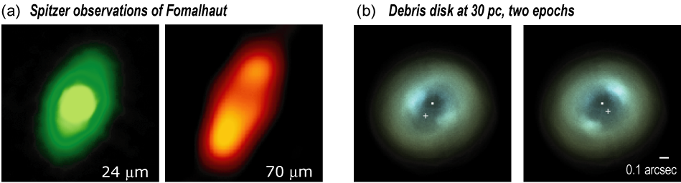

Figure 1 –Spitzer resolves four nearby debris disks, including Fomalhaut, shown here (a) at 24 and 70 μm.^{[9]} A far-IR observatory with angular resolution a hundred-fold better than that of Spitzer could provide clear images of a large statistical sample of debris disks, enabling discoveries of new planets and a great improvement in our understanding of the factors that influence the evolution of planetary systems. The model images in (b), based on Eps Eri but scaled to 30 pc, show the predicted far-IR emission at 40, 60, and 100 μm color-coded as blue, green, and red, respectively. The dust-trapping planet (+) is shown at two orbital phases, and the resonantly trapped dust grains can be seen to have moved.

1.2 Characterize gas and ice giant exoplanets to constrain models of planetary system formation
To understand planet migration and gain insight into the planet formation process, it will be imperative to characterize giant exoplanets at all orbital radii. Recent Spitzer observations of transiting extrasolar giant planets demonstrate the value of IR spectroscopy as a tool to constrain a planet’s temperature structure and probe the composition of its atmosphere.^{[10]} Soon JWST observers will be able to use the same technique to probe dimmer planets and fainter spectral features. However, transiting planets tend to be in close orbits and preferentially tell us about “hot Jupiters.” Exoplanets in distant orbits, like the gas and ice giants in our own solar system, have a very low probability of being seen in transit. An alternative technique is needed to characterize such planets.
The spectra of non-transiting giant exoplanets could be measured with a Michelson stellar interferometer equipped with a Fourier Transform Spectrometer, a so-called “double Fourier” interferometer. To such an instrument the planet’s light would appear as the modulating signal component when the baseline position angle is varied, while starlight would produce a stable fringe pattern. With sufficient signal-to-noise ratio, the planet’s interferogram could be extracted and Fourier transformed to obtain the desired spectrum, and the planet’s orbital position could be measured.
In the far-IR, where the planet-to-star contrast ratio is at a maximum (Figure 2, left), starlight nulling is not necessary and detection is possible if the exoplanet is separated from the star by an angle greater than λ/2B, where λ is the wavelength and B is the length of the interferometric baseline. Taking Jupiter as an example (Figure 2, right), we can expect to detect broad NH₃ bands, which dominate the spectrum from 40 to 100 μm, and to study the abundances of key chemical species such as water and methane. The observed spectra of giant planets, when coupled with independent planet mass estimates (e.g., from the debris disk sculpting method described above), will test models for planetary atmospheres and serve as an empirical set of spectral benchmarks.
The proposed spectroscopic measurements will be challenging, but not more difficult than the differential measurements (star + planet minus star) required in the transiting technique. A structurally connected infrared interferometer of modest size (~40 m) could probe planets at 0.1 arcsec orbital radii (i.e., 1 AU at 10 pc).
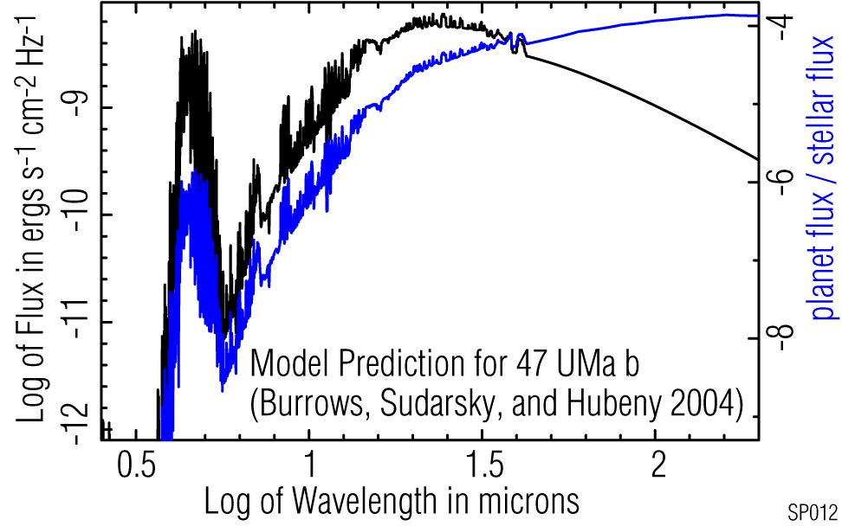
Figure 2. Left panel: The atmospheres of giant planets will be seen in highest contrast relative to their parent stars in the far-infrared. Right panel: This spectrum of Jupiter from the Cassini Composite Infrared Spectrometer shows CH₄, NH₃, and PH₃ absorption lines and was used to place chemically interesting limits on the mole fractions of HF, HCl, HBr, and HI in the jovian troposphere.^{[11]}
How common are planetary systems like our own? The discovery and characterization of planets in distant orbits around stars with a wide range of masses, ages and heavy element concentrations, will dramatically advance the burgeoning field of comparative planetology and provide stringent new tests of theoretical models for planet formation.

1.3 Observe the transition from protoplanetary to debris disks to learn the effects of gas dissipation on planet formation
A white paper by Mundy et al. will discuss observational methods to probe the early phases of star and planetary system formation. Here we discuss the interesting transition phase between a gas-rich proto-planetary disk and an older debris disk from which the gas has vanished. When does gas dissipation occur, and how does this affect the migration of planetary bodies and the outcome of the planet formation process? How does the dissipation process depend on the heavy element composition of the protoplanetary nebula, the mass of the newborn star, and the environment in which star formation takes place?
By measuring the gas contents of planet forming disks of various ages it will be possible to constrain the timescale for gas giant planet formation and the migration of planetary bodies of all sizes. Spitzer has already enabled pathfinding studies.^{[11]} The Herschel Space Observatory will observe disks in the far-infrared, measuring numerous lines from hydrides, such as CH and OH, and the strong [C I], [O I] and [C II] fine structure lines at 370, 146, 63 and 158 μm. When coupled with models,^{[13,14,15]} far-IR spectral line observations will give us new insight into the chemistry and physical conditions in young planet forming disks. The C/O ratio, derivable from these observations, is thought to affect the composition, surface chemistry, and perhaps the habitability of planets.^{[16,17]}
Following closely behind Herschel, ALMA and JWST will play major roles in studies of gas-rich and gas-poor disks. With ALMA we will be able to make spectral line maps in surrogate tracers of total gas density, such as ¹²C¹⁶O and its less abundant isotopes. Unfortunately, total gas density estimates based upon measurements of such proxies can be significantly biased, as CO molecules can be photodissociated or frozen onto grain surfaces. JWST will attack this problem head-on by directly measuring the readily excited 17 and 28 μm rotational lines of H₂.
JWST will measure the total gas contents of disks, but its spatial resolving power will be insufficient to make spectral line maps analogous to those of ALMA. To make further progress and definitively answer the questions posed above, we need to map the H₂ 28 μm line emission, emission in the easily excited but weaker HD line at 112 μm, and the plethora of diagnostic and cooling lines accessible to Herschel.

1.4 How does water reach the surface of a planet?
Water will be one of the most interesting molecules to observe in nascent planetary systems because of its biological significance. We owe our existence as a species to the presence of liquid water on the Earth’s surface. Most of the volatiles found on the terrestrial planet surfaces are thought to be delivered by impacts of small water-rich bodies from the outer solar system. New observing tools will be needed to study the formation of water reservoirs in developing planetary systems and to search for evaporating water in extrasolar comet trails.^{[18,19]}
Herschel will observe water spectroscopically in young stellar objects and their parental molecular clouds, but this 3.5 m telescope lacks the angular resolution to map the distribution of water in forming planetary systems. ALMA will have the resolving power but will not be able to detect water vapor through the atmosphere, or perhaps will detect it with a low signal-to-noise ratio.
A future space observatory with suitable spectral resolving power and sub-arcsecond imaging capability will be able to access the rich far-IR spectrum of H₂O and map its distribution in young exoplanetary systems (Figure 3). In addition to spectral line maps of H₂O in the gas phase, complementary maps of the water ice features at 44 and 63 μm^{[20]} will paint a complete picture of the distribution of water in exoplanetary systems, ultimately enabling us to understand how water reached our own planet.
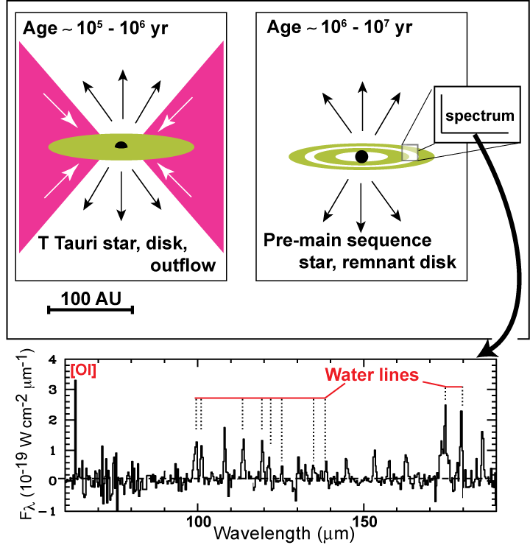
Figure 3. A future far-IR observatory will map the distribution of water in protostellar and protoplanetary disks. The continuum-subtracted spectrum (bottom panel) is based on Infrared Space Observatory observations of a Class 0 protostar.^{[21]}

2.0 Measurement capabilities
To discover the diversity of planetary systems and understand how planets form, new measurement capabilities will be required, surpassing those available in observatories currently under development, such as Herschel, JWST, and ALMA. Instead what is needed are sensitive, space-based far-infrared measurements in the wavelength range 25 to ~200 μm, with spectral resolving power λ/Δλ ~ 3000 or greater, and, most importantly, angular resolution a hundred-fold better than that of Spitzer. To study the early gas-rich phase, when giant planets form, objects in regions like ρ Oph and Taurus, at 140 pc, will be targeted. The gas-poor terrestrial planet formation phase of disk development can be observed in the Tuc or TW Hya associations, whose distances are ~50 pc. Sub-arcsecond angular resolution is essential to resolving the spatial structures of interest.
We already know the instrumental requirements needed to implement a far-IR interferometer capable of meeting the goals described here. NASA has supported the study of a mission called SPIRIT^{[22]} – the Space Infrared Interferometric Telescope – which would provide all of the measurement capabilities needed to accomplish the science objectives described in Section 1.

3.0 References

^{[1]} Ozernoy, L.M., Gorkavyi, N.N., Mather, J.C., and Taidakova, T.A. 2000, ApJ, 537, L147
^{[2]} Moran, S.M., Kuchner, M.J., and Holman, M.J. 2004, ApJ, 612, 1163
^{[3]} Kalas, P., Graham, J.R., Clampin, M.C., and Fitzgerald, M.P. 2006, ApJ, 637, L57
^{[4]} Stapelfeldt, K.R. et al. 2004, ApJS, 154, 458
^{[5]} Wilner, D.J. et al. 2002, ApJ, 569, L115
^{[6]} Koerner, D.W., Sargent, A.I., and Ostroff, N.A. 2001, ApJ, 560, L181
^{[7]} Debes, J.H., Weinberger, A.J., and Schneider, G. 2008, ApJ, 673, L191
^{[8]} Stark, C.C. and Kuchner, M.J. 2008, ApJ, 686, 637
^{[9]} Stapelfeldt, K.R. et al. 2004, ApJS, 154, 458
^{[10]} Richardson, L.J. et al. 2007, Nature, 445, 892
^{[11]} Fouchet, T. et al. 2004, Icarus, 170, 237
^{[12]} Roberge, A., and Weinberger, A.J. 2008, ApJ, 676, 509
^{[13]} Glassgold, A.E., Najita, J., and Igea, J. 2004, ApJ, 615, 972
^{[14]} Kamp, I. et al. 2005, in Astrochemistry: Recent Successes and Current Challenges, Proc. IAU Symp. 231, eds. D.C. Lis, G.A. Blake & E. Herbst (Cambridge: Cambridge Univ. Press), 377
^{[15]} van Dishoeck, E.F. and Hogerheijde, M.R. 1999, in The Origin of Stars and Planetary Systems, eds. C.J. Lada and N.D. Kylafis (Kluwer Acad. Pub.), 97
^{[16]} Kuchner, M.J., and Seager, S. 2006, ApJ, submitted. <http://arxiv.org/abs/astro-ph/0504214>
^{[17]} Larimer, J. W. 1975, Ge CoA, 39, 389
^{[18]} Ford, K.E.S. and Neufeld, D.A. 2001, ApJ, 557, L113
^{[19]} Jura, M. 2005, AJ, 130, 1261
^{[20]} van Dishoeck, E.F. 2004, ARAA, 42, 119
^{[21]} Nisini, B. et al. 2000, A&A, 360, 297
^{[22]} Leisawitz et al. 2007, J. Adv. Sp. Res., 40, 689 (SPIRIT “Origins Probe” study report)

NASA GSFC; ^{b} Caltech; ^{c} NASA Postdoctoral Fellow; ^{d} Jet Propulsion Laboratory; ^{e} U Maryland; ^{f} NOAO; ^{g} Johns Hopkins U; ^{h} IPAC; ^{i} UCLA

