CHARA Small (lab) Deformable Mirror Optics

If funding for a large DM at M4 does not eventuate (update Jan 2012: no funding now), CHARA will need to create a cheap AO system using deformable mirrors in the lab. The typical desired pupil conjugation is a setup like W1 or E1 on POP1 (a typical POP for those telescopes), which means a pupil location ~180-260m upstream from the beam reducing telescopes. Using other POPs will push this number higher. The key parameters for the AO setup are then:

- Pupil location 200-300m upstream from the BRTs.
- Small actuator count – e.g. ~20 degrees of freedom OK.
- A preference to keep the current primary for the BRTs, which has a 1280mm focal length.
- A maximum of 400mm additional length spare between the LDCs and the metrology optics.
- An input beam diameter of 125mm and an output beam diameter of 20mm (exact numbers?)

Some nominal parameters are described in the CHARA_LabAO.xlsx spreadsheet. A baseline configuration consists of:
- A -1000mm focal length mirror 70mm before the BRT focus, mounted on a Newport U100 mount.
- A 2.0mm pupil small (i.e. medium-sized, available from Thorlabs) DM from Boston Micromachines, placed 90.5mm further downstream. This needs at least 40.4mm clearance from any beam – detailed geometry on the Thorlabs drawing.
- A custom 238mm focal length paraboloid, 218mm further downstream. I suggest we get quotes for these, from e.g. Robert F Royce optics, and Ranbow Research Optics. We could check if a spherical mirror plus a correction term on the DM is adequate.

This doesn’t actually work, because of coma produced by the -1000mm focal length mirror. Replacing it with a flat and a lens seemed to work, as in the diagram below… but this isn’t ideal. Almost certainly there is a solution with appropriate conic constants and angle-of incidences.

Figure 1: The beam reducing telescope, with the secondary replaced with a negative focal length lens, a flat mirror, a DM (red box) and an off-axis paraboloid.

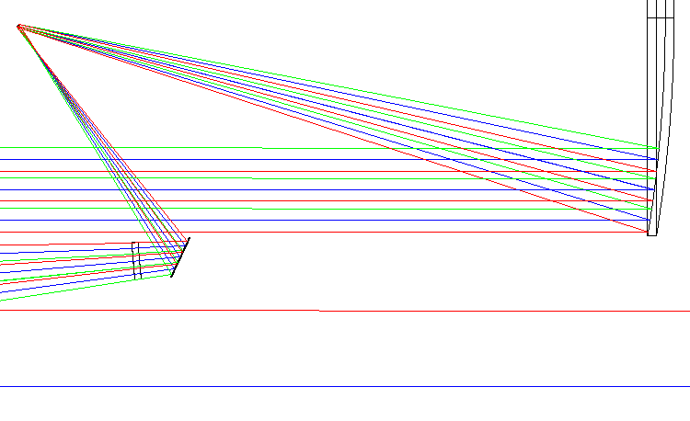
Figure 2: A zoom in to the focus region, where the 3 colors are field angles of 0 and +/- 20 arcsec (i.e. +/- 2.5 arcsec on sky). All field angles strike the DM as it is in the pupil plane.

