S2 New Finder Camera
Temporary procedure for routine observations written by Judit on 7/5/2017
Approved by Theo on 7/6/2017

In this write-up the actions of Cosmic Debris are not accounted for. At this time only S2 telescope has the new Zwo finder camera.
- The new finder server is running on s2wfs computer ./zwo_server S2 &
It is most likely running, if not, consult the document on how to restart servers.

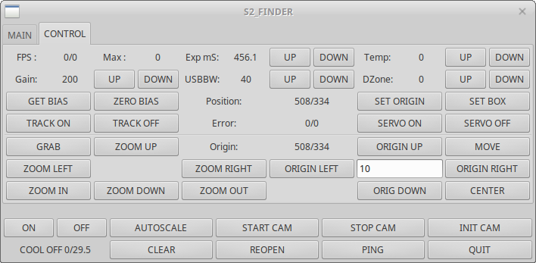
- To start a GUI hit the FINDER button in the S2 telescope GUI

- Turn ON cooling in the bottom left.
You can see the status of the cooling: in this case it is OFF. Next you see the target temperature and the current temperature. Leave the default target temperature at 0 in the summer. Once you turned the cooling ON the temperature should start to go down.
- Press START CAM, and the camera image with tick marks will appear in a new window. You will also see more feedback in the GUI: current and max frame rate (FPS, Max),
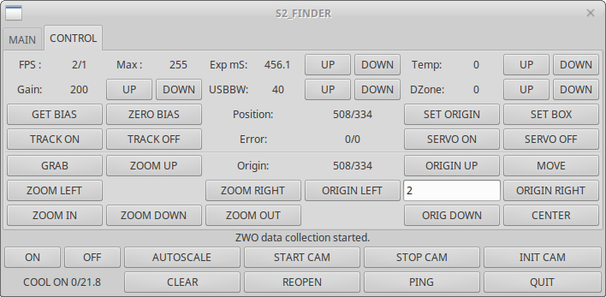

- The origin of the Finder was set [S2 (508, 334)] when the telescope was aligned, and should not be changed. Do not press SET ORIGIN !! These are the coordinates where the star has to be placed in order to have the least aberration in the M1-M2 system. When at the Finder origin, the star has to appear in the Acquisition camera. If you have the star at the Origin and do not see it in the Acquisition camera, something has gone really bad; report the fact to Laszlo. At the expense of image quality, you could perhaps use the scope when the star is not at the Finder origin.

- Depending on the target star you can adjust the “Gain” and “Exp ms” at the top of the GUI.

- To get the star to the origin hit SET BOX, click to the upper left and then lower right of the target star. This sets a box around the star. Then hit CENTER, and the star will be automatically pulled to the Origin. Failing that, you could still use the PADDLE in the telescope server.
- The MOVE and GRAB buttons should also work the same way as in the telescope servers.
- Once the star is in the Finder origin, it should also be close enough for the tip tilt to see the star and take over to hold it. If not, that means that the alignment laser is not overlapping with the star yet. Adjust the telescope pointing until the laser and star overlap in Acquisition.
  - Adjust Acquisition ticks to one of the laser spots
  - Close the laser
  - Use the MOVE or GRAB in the telescope GUI to pull the star in place in the Acq.TV, make sure you moving the corresponding star image.
  - If you could, it would be good to note the position of the star in the Finder when locked in tip tilt. Ideally it should stay close to Origin, if not, we would like to know, because that should be investigated.

